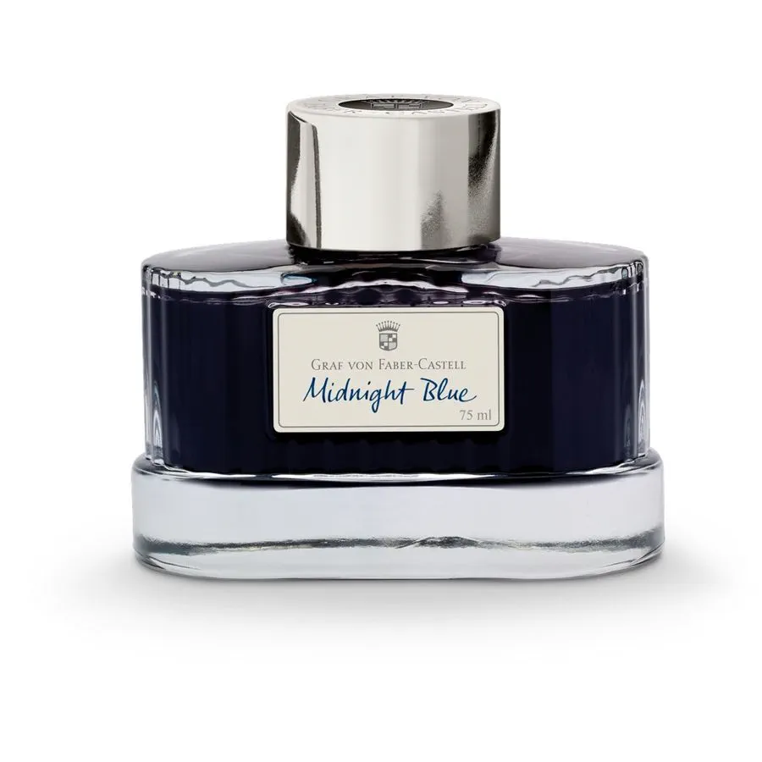

# **Ink bottle Midnight Blue**

Product details

* Midnight Blue, document-proof
* Available in 18 other colors inspired by nature
* Proprietary formulation based on the highest-quality dyes
* High color brilliance and flowability
* 75 ml (about 2.54 oz) in elegant ink glass

Ink bottle Midnight Blue, 75ml (about 2.54 oz)

The manufacture of our indelible inks for fountain pens is an art form. Each one of our different vibrant colors inspired by nature requires its own formula and the highest quality ingredients. The excellent quality shows itself in the even flow of ink and the fact that you can start writing with the fountain pen almost immediately, even after long breaks. An ink is designated as being indelible (as per DIN ISO 12757-2) if it is smudge-resistant, reproducible, light-fast, resistant to many chemicals and solvents and cannot be erased. This ink is also water-resistant, which means it may run when exposed to water, but the writing lines will remain visible. The elegant glass bottle of ink becomes a precious ornament for every desk. All Graf von Faber-Castell inks are also available as ink cartridges.